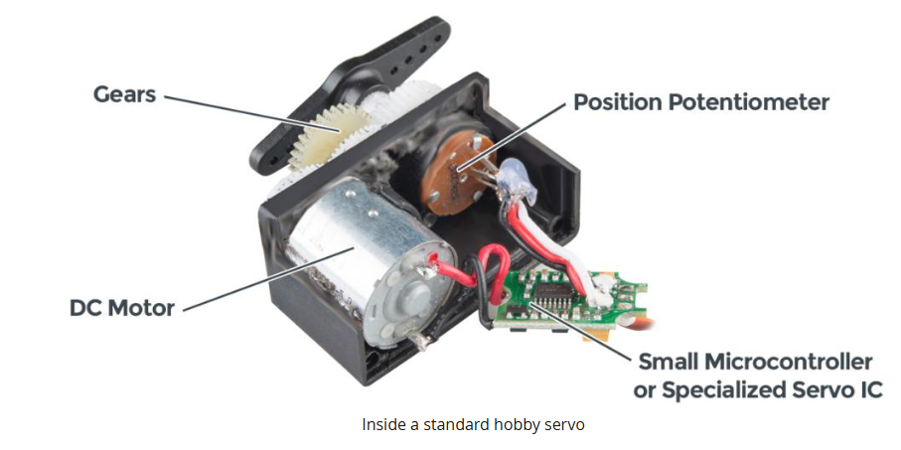Anatomy of a servo motor

* DC motor – drives the output shaft
* Small microcontroller – interprets signals sent by the controller
* Position Potentiometer – feedback for the controller circuit to monitor the position of the output shaft
* Gearbox & shaft for servo rotation

Controlling a servo

* Controller needs to send a precisely timed signal for the servo to interpret
* Typical hobby servos expect to see a pulse every 20ms and the width of this signal determines the position
  + This width is usually 1-2 ms
* This is called PWM (Pulse Width Modulation)

How to Calculate the minimum Angle change in a servo motor:

* Look at Controller PWM Resolution (Ex: 1000-2000micro, seconds)
* Steps = 1000 PWM steps
* If the servo rotates over that PWM range: 180 degrees/1000 steps = 0.18 degrees/step
* Look at Servo Internal Resolution
  + 8 bit potentiomenter: 2^8 = 256 steps -> 180 degrees/256 = 0.7 degrees/step
  + Look at the servo micro controllers resolution

Example: Controlling MG90S with Arduino Microcontroller

* Pulse Width Range of Arduino (544-2400 microseconds)
* Pulse Width Range of MG90s (1000-2000 microseconds)